**Ideation Phase**

**Empathize & Discover**

|  |  |
| --- | --- |
| Date | 16 June 2025 |
| Team ID | LTVIP2025TMID55634 |
| Project Name | Booknest: Where Stories Nestle |
| Maximum Marks | 4 Marks |

**Empathy Map Canvas:**

An **empathy map** is a simple yet powerful visual tool that helps teams gain a deeper understanding of their users’ behaviors, attitudes, and experiences. It plays a crucial role in user-centered design by encouraging teams to step into the user’s perspective, considering what they think, feel, say, and do. This process helps uncover the user's goals, needs, and pain points, which are essential for identifying the true problem behind a challenge. Creating an empathy map fosters collaboration, promotes shared understanding among team members, and ensures that solutions are designed with genuine user insights in mind. By grounding decisions in empathy, teams are better equipped to create meaningful, effective, and user-focused solutions.

**Example:**

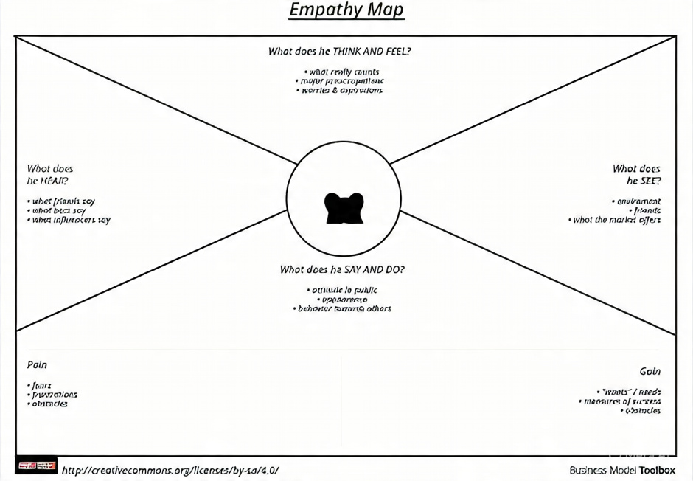

**Example: Booknest – Online Book Store**

